Entity relationships

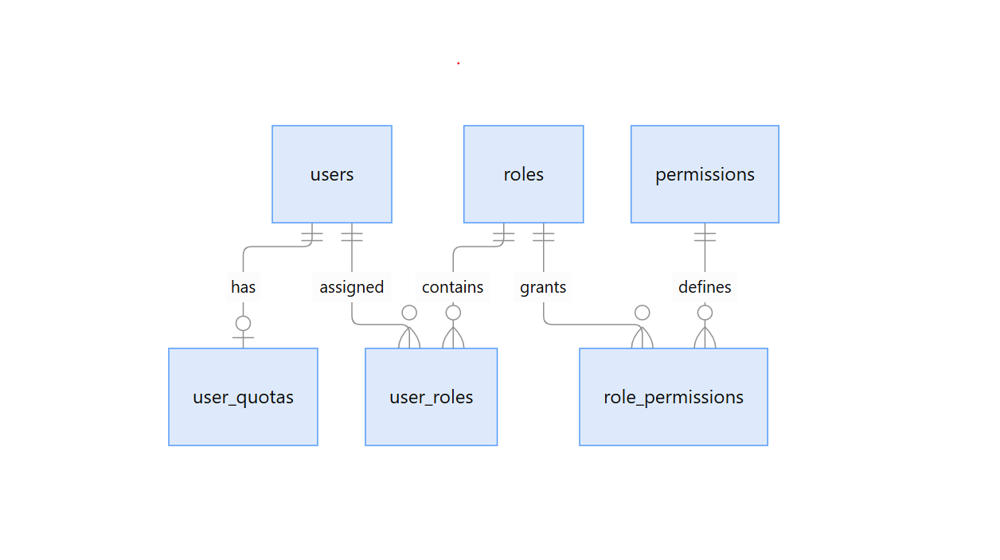Users: Stores application user information

Roles: Examples of roles could include admin, uploader, and viewer

Permissions: Represents read/upload/delete
users
Field | Data type | Constraints | Index
id | UUID | Primary key; generated | PRIMARY KEY
external_id | VARCHAR(255) | NOT NULL; UNIQUE | UNIQUE
email | VARCHAR(320) | NOT NULL | B-tree
display_name | VARCHAR(255) | Nullable | —
is_active | BOOLEAN | NOT NULL; DEFAULT TRUE | —
created_at | TIMESTAMPTZ | NOT NULL; DEFAULT NOW() | —
updated_at | TIMESTAMPTZ | NOT NULL; DEFAULT NOW() | —
roles
Field | Data type | Constraints | Index
id | BIGINT | Identity; primary key | PRIMARY KEY
name | VARCHAR(100) | NOT NULL; UNIQUE | UNIQUE
description | TEXT | Nullable | —
created_at | TIMESTAMPTZ | NOT NULL; DEFAULT NOW() | —
permissions
Field | Data type | Constraints | Index
id | BIGINT | Identity; primary key | PRIMARY KEY
resource | VARCHAR(100) | NOT NULL | UNIQUE (resource, action)
action | VARCHAR(100) | NOT NULL | UNIQUE (resource, action)
description | TEXT | Nullable | —
user_roles
Field | Data type | Constraints | Index
user_id | UUID | NOT NULL; FK → users.id | Composite PK (user_id, role_id)
role_id | BIGINT | NOT NULL; FK → roles.id | Composite PK; B-tree on role_id
assigned_at | TIMESTAMPTZ | NOT NULL; DEFAULT NOW() | —
role_permissions
Field | Data type | Constraints | Index
role_id | BIGINT | NOT NULL; FK → roles.id | Composite PK (role_id, permission_id)
permission_id | BIGINT | NOT NULL; FK → permissions.id | Composite PK; B-tree on permission_id
user_quotas
Field | Data type | Constraints | Index
user_id | UUID | PK; FK → users.id | PRIMARY KEY
limit_bytes | BIGINT | NOT NULL; CHECK >= 0 | —
used_bytes | BIGINT | NOT NULL; DEFAULT 0; CHECK >= 0 | —
updated_at | TIMESTAMPTZ | NOT NULL; DEFAULT NOW() | —

